Personal Development &
Name:
Block:
Date:
CLE 10

the Core Competencies

Your Assignment is to a draw a “Core Competencies” mind map (see instructions below). Your mind map should have the title “Personal Development” as the central theme. The main branches should be the 6 core competencies:
- Communication | - Creative thinking
- Critical thinking | - Personal and cultural identity
- Personal awareness and responsibility | - Social responsibility

You will be marked on information, detail, neatness, illustrations, and the criteria below:
- Start in the CENTER of a blank page turned sideways (landscape)
- Use an IMAGE or PICTURE for your central theme
- Use colours throughout
- Connect your MAIN BRANCHES to the central idea and connect your second and third branches to the first and second levels
- Make your branches CURVED rather than straight
- Try to use ONE or TWO key words per line or very short phrases/examples
- Use images throughout if you are not good at drawing you can use printed images and glue them on.
Satisfactory criteria: you should have at least THREE branches from each competency (competency 3 secondary branches) OR TWO secondary branches from the competency with a minimum of 2 third branches (competency 2 branches each branch has 2 more branches)
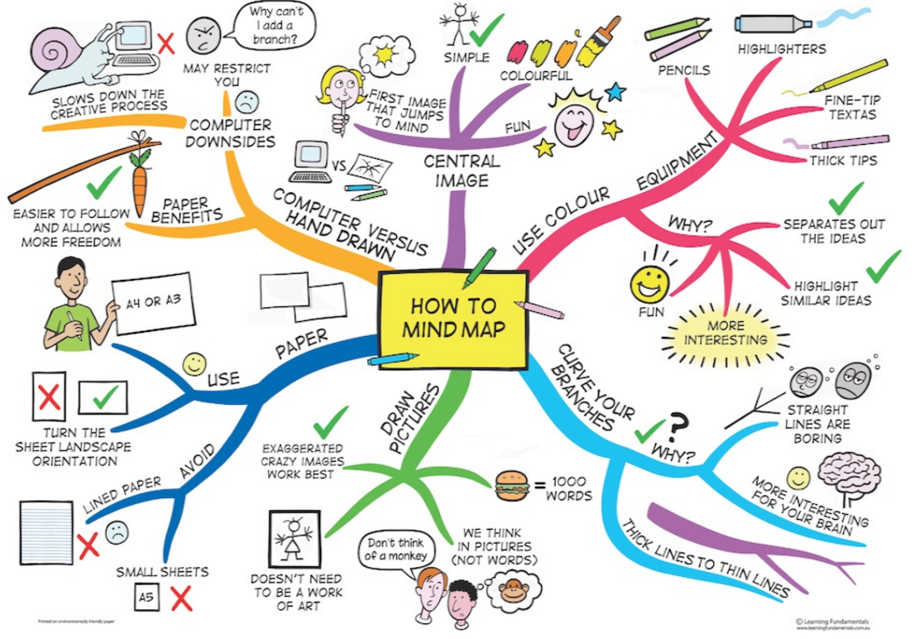

CRITERIA | PERFORMANCE INDICATORS
 | Level 1 | Level 2 | Level 3 | Level 4
Depth of coverage  (Knowledge) | - Bare minimum of content covered  - No extension of ideas evident | - Shows a basic level of coverage of key ideas only  - Attempts extension of a few ideas | - Shows a solid grasp of most of the content  - Shows extensions of most key ideas | - Shows a solid grasp of all the content covered  - Extensions of the key ideas show a deep understanding of the content
Radiance | - Does not contain all 6 competencies with <3 branches or equivalent | - 6 competencies with <3 branches from each competency or equivalent | - 6 competencies with 3 branches from each competency or 2 and 2 branches | - 6 competencies with >3 branches from each competency or 3 branches with 2+ minor branches
Ideas radiate out from central image and from most to least complex  (Application) | - Some ideas are connected to and radiate out from centre  - Some confusion in moving from most to least complex | - All ideas radiate out from centre  - Still some confusion in moving from most to least complex | - Ideas clearly connect to central image and ideas  - Generally moves from most to least complex | - Ideas clearly connect to central image and ideas  - Consistently and accurately shift from most to least complex
Key words/ Ideas/ Images | - A little evidence of key images. Has only a few keywords | - Images and keywords are evident, but either too few or some are imprecise | - Images and key words clearly show an understanding of the content | - Images and key words clearly and dynamically show an understanding of the content. (One or more of: use of metaphor, humour, cut-outs from magazines, clipart, illustrations.)
Colour or codes or links used to illustrate connections between ideas  (Thinking) | - A little use of colour, codes or links to illustrate connections between ideas | - Obvious attempt is made to use colour, codes or links to enhance clarity and memory. Still some inconsistency of application | - Clearly uses colour, codes, or links to clarify connections and to assist with memory for most aspects of Mind Map | - Effectively uses colour, codes, or links to meaningfully clarify connections for all aspects of Mind Map
Neatness | - The mind map is not readable. (This may affect other portions of the grade). | - The mind map is not very neat and orderly. The mind map is readable. | - The mind map is somewhat neat and orderly. The mind map is clearly readable. | - The mind map is very neat and orderly. The mind map is clearly readable.
Spelling/ Grammar | - 5+ errors | - 3-4 errors | - 1-2 errors | - No errors

Core Competency Prompting Questions and Reflections
Communication- involves the ability to impart and exchange information, experiences, and ideas, to explore the world around them, and to understand and effectively engage in the use of digital media. It is the bridge between your learning, your personal and social identity and relationships and the world in which you interact with.
- What feedback helps you learn?  - How do you share information with others?  - How do you collaborate with others?  - What is your strength in group work?  - Are you an active listener? | - What role is easy for you/difficult for you?  - What do you do when you disagree?  - What strategies do you use to present information clearly?  - What are some ways you can show your learning?

Creative Thinking- involves the generation of new ideas and concepts that have value to the individual or others, and the development of these ideas and concepts from thought to reality
- Where do your new ideas come from?  - Developing ideas  - Novelty | - Describe when you helped build on ideas from others  - What personal strategies do you use to generate ideas?  - What inspires you?

Critical Thinking- making judgements based on reasoning: you consider options; analyze these using specific criteria; and draw conclusions and make judgments. You can examine your own thinking, and that of others, about information that you receive through observation, experience, and various forms of communication.
- Process: the doing (getting ideas)  - Evidence (connections, reliability, examples)  - What didn’t work and why? | - What strategies do I use to solve problems?  - Analyzing (compare/contrast)  - Critique: How do you know you were successful?

Positive Personal and Cultural Identity - awareness, understanding, and appreciation of all the facets that contribute to a healthy sense of oneself. Includes awareness/understanding of one’s family background, heritage(s), language(s), beliefs, and perspectives in a pluralistic society.
- What makes you unique?  - What are my learning strengths?  - Describe your family and community | - What is most important to you?  - Explain what my values are and how they affect choices I make  - Identify the different groups that I belong to
Personal Awareness and Responsibility: includes the skills, strategies and dispositions that help you to stay healthy and active, set goals, monitor progress, regulate emotions, respect their own rights and rights of others, manage stress, and persevere in difficult situations.
- What are my strengths?  - What are my weaknesses?  - How do I keep myself healthy?  - How do I make good choices? | - What do I enjoy doing?  - What am I good at?  - What do I do when I struggle with something?

Social Responsibility - involves the ability and disposition to consider the interdependence of people with each other and the natural environment; to contribute positively to one’s family, community, society, and environment; to resolve problems peacefully; to empathize with others and appreciate their perspectives.
- Identify when others need support and provide it  - Participate respectfully in group activities | - Make the lives of others better  - Taking care of the environment
- Clarify problems or issues generate multiple strategies weigh consequences compromise to meet the needs of others evaluate actions

