Core Competencies

What are they?
They are a set of intellectual, personal and social competencies that students develop over the course of their schooling.
There are 3 competencies:
- Communication
  - The Communication competency encompasses the set of abilities that students use to impart and exchange information, experiences and ideas, to explore the world around them, and to understand and effectively engage in the use of digital media.
- Thinking
  - The Thinking competency encompasses the knowledge, skills and processes we associate with intellectual development.
  - It is through this competency that students take subject-specific concepts and content and transform them into a new understanding.
  - Thinking competency includes Creative Thinking and Critical Thinking.
- Personal & Social
  - Personal and Social competency is the set of abilities that relate to students’ identity in the world, both as individuals and as members of their community and society.
  - Personal and Social competency encompasses the abilities students need to thrive as individuals, to understand and care about themselves and others, and to find and achieve their purposes in the world.
  - The Personal and Social competency includes Positive Personal & Cultural Identity, Personal Awareness and Responsibility and Social Responsibility.

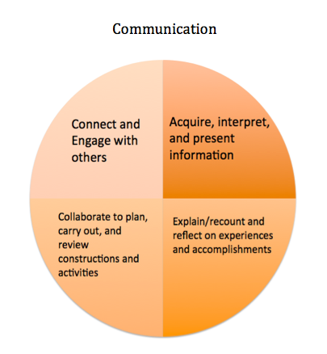
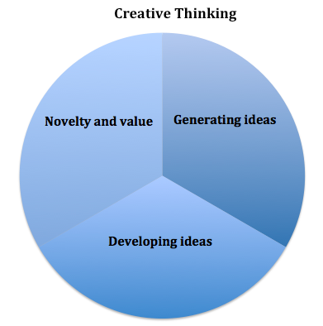
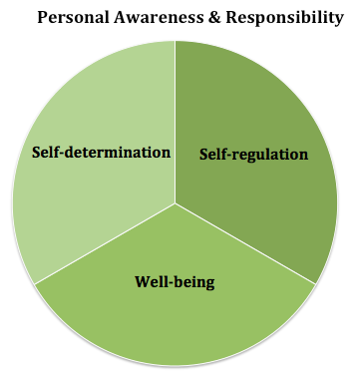

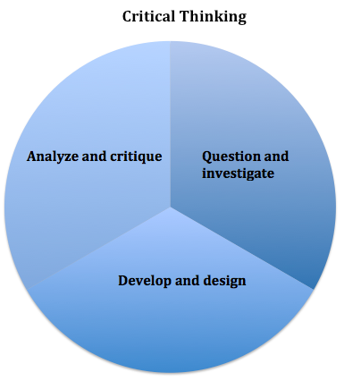

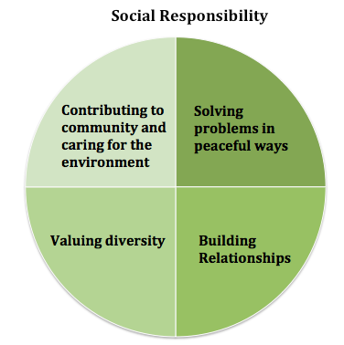
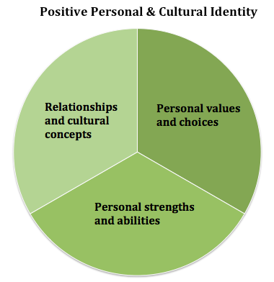
Communication Gradual Growth Statements
- When comfortable, I can communicate, share information, and plan activities with others; I can also talk and listen to people I know.
- I can participate in friendly conversations when helping, or sharing basic information. I can work with others and do my share of the work. I can share out on what I did and learned.
- I am gaining confidence with peers and adults. I can listen, ask questions, and encourage others to do the same.
- I can communicate clearly and can share my ideas. I actively listen and ask clarifying questions. I can plan and work with others to develop plans while giving and receiving constructive feedback.
- I can gather information easily from a variety of reliable sources. I know my audience and have a clear purpose when I present.
- I can contribute positively to discussions and work well in collaborative environments with my peers.
- I am a good communicator, I am clear and well thought out when speaking to different audiences. I also listen to others ideas and see similarities in topics.
- I can draw on a variety of strategies and experiences when leading and supporting groups.
- I can acquire, analyze and create well written pieces of work from a variety of texts.
- I can be a leader and am supportive of others.
- I am a flexible thinker, and am able to reflect and move forward with new goals.
- I can communicate through technologies well.
- I can be a leader when collaborating and help take thinking and learning deeper.
- I know who I am and can communicate this clearly. I am clear with my goals and progress in work and learning.

Creative Thinking Gradual Growth Statements
- I can change my ideas if things are not working for me.
- I can create new things or solve problems using my own ideas, others ideas or building on others ideas.
- I can and like to learn about new things so that I can come up with new ideas.
- I can learn new skills to make my new ideas work even if it takes me a few tries.
- I can come up with ideas that help my peers.
- My creative ideas are usually a form of self-expression for me.
- I can take a brain-break when I need so that I am more creative when I get back to my work.
- I can continually build on creative pieces when it’s in an area of interest to me.
- I can make a difference in my community or beyond using my creativity.
- I pursue my interests and passions.
- I am willing to take risks in my thinking and am okay with uncertainty, failure and setbacks as they help advance my thinking.
Critical Thinking Gradual Growth Statements
- I can explore learning, ask questions, make predictions and use what I learn. I can talk about or show something about my thinking.
- I can come to conclusions and make decisions based on experiences, things I saw, and what I think might happen.
- I can ask open-ended questions, gather information and experiment to try and develop options for problems or curiosities.
- I can describe my thinking and how it is changing.
- I can gather evidence to gain knowledge to answer problems, make plans or make a decision.
- I can use what I know and observe to identify problems and ask questions.
- I can think about and consider more than one way to make decisions.
- I can develop criteria, assess my thinking, and come to conclusions, judgements or plans.
- I am flexible and open-minded. I can examine my thinking, get feedback, reflect on my work and make new plans.
- I can gather and evaluate resources at a high level (identify alternatives, perspectives, implications) and ask further questions and draw conclusions.
- I can examine evidence from a variety of perspectives and make decisions on complex issues.
- I can consider alternative approaches and make strategic choices.
- I can develop my own criteria and plans for tasks that involve critical thinking.
- I can consider views that do not match my beliefs; I am patient, open-minded, and understanding.
- I can take the results of my inquiries and make further action plans.
Personal Awareness and Responsibility Gradual Growth Statements
- With support, others can see that I am proud and happy with myself. I sometimes recognize my emotions.
- I can let people know what I want, need and choose over other things.
- I can manage my feelings and emotions.
- When feeling safe and with support, I can share and be responsible for what I have done.
- I understand that my actions have consequences and I can manage my feelings and emotions.
- I can express my wants and needs and celebrate when I try something or accomplish something.
- I can manage my stress and complete goals.
- I can create realistic goals and try hard to complete them. I persevere when tasks are challenging for me.
- I can recognize and control myself when upset.
- I know how to be safe in a variety of communities, including online.
- I accept myself and advocate for myself when I need to. I take responsibility for my actions.
- I can take responsibility for my learning: set priorities, plan, adjust plans and reflect on the results, seeking help when I need it.
- I work on having a balanced lifestyle and keeping myself happy and calm.
- I know how to find social support if I need or want it.
- I know my strengths and where I could grow and develop. I make ethical decisions when I can.
- I set goals for myself and work on them when I can.
- I make decisions and talk with others if they don’t like them, or if they were affected by them.
- I am aware of my personal journey and take time to reflect and grow regularly.
- I can advocate for myself in stressful situations.
- I take time to learn about controversial issues and try to understand the more ethical side.
Positive Personal and Cultural Identity Gradual Growth Statements

- I am aware of myself and am different from others.
- I know my name and with support I can talk about who I am and what makes me different from others.
- I am aware of the different aspects of myself and can identify some of my features and qualities.
- I can identify people, places and things that are important to me including my family, home and community.
- I can explain what I like, dislike and what interests me.
- I have pride in who I am and can talk proudly of myself and my abilities.
- Through words and/or images, I can talk about my family, communities, school, and peer groups and how I contribute to them.
- I understand that who I am (my identity) and what I do is influenced by the people and groups around me.
- I understand that experiences, family history, heritage, where I live, and groups that I feel connected to (family, friends, online communities) help to make up who I am and the choices that I make.
- I understand that who I am / who I have become is a unique person and I am important to my communities (family, social, etc.)
- I know that my identity will continue to develop over time and is always changing.
- I can describe why I value and choose certain things over others.
- I understand that challenges are opportunities for personal growth and that I will continue to grow over my lifetime.
- I can identify my potential as a leader within communities that I am a part of.
Social Responsibility Gradual Growth Statements
- I am aware that people are different than me.
- I can solve problems myself and I can ask for help if I need it.
- I know when others need help and with some help, I can be inclusive to support them.
- I can interact with others well and can make good friends with whom I choose.
- I contribute to groups and help make my communities a better place to be.
- I consider other people’s opinions and can express my opinion in a nice way.
- I can identify problems and can come up with strategies to solve them.
- I can be inclusive and respectful and know when something is unfair.
- I recognize when others need support and can provide it, including elders.
- I understand that my actions and the actions of others can make a positive difference.
- I can clarify problems or issues, I can consider alternatives and consider strategies.
- I understand that we are all different and I demonstrate an inclusive behaviour.
- I can advocate for others.
- I can establish and keep relationships with younger and older people.
- I can create positive changes for people and the environment.
- I can analyze complex social and / or environmental issues and can take action to help make positive changes.
- I am good at clarifying issues or problems, coming up with strategies, consider consequences and am flexible with coming up with solutions that work for most.
- I support and defend human rights and recognize that differences are good for my communities.
- I can build and sustain good relationships with people from a variety of age groups, communities and cultures.
- I can empathize with others and can adjust my behaviour to accommodate their needs.

