Recognize and explore diverse perspectives on how work contributes to our community and society
Day 1
- What does “work” mean to you? ---students define (5-10 minutes) then “why do we work?” brainstorm. Share with class.
  - Watch “Alike” short film. https://youtu.be/kQjtK32mGJQ
  - Why we Work TED : https://www.ted.com/talks/barry_schwartz_the_way_we_think_about_work_is_broken
- Maybe we need to shift our perspective: Master Narrative PPT : what is strong, beautiful…can be defined in different ways.
- Read “True Story of the 3 Little Pigs” or “Where Oliver Fits” –there is more than one way to view an issue
- What can/should a work day look like? What purpose should work serve? Can it serve different purposes at different points in our life?
Day 2
- Watch “For the Birds” Pixar short. https://youtu.be/AkFuvTHaMUE
- What is teamwork? How does it apply to our community?
  - What if we did not have police officers? Construction workers? Nurses?
- Capitalist view of work: I get richer and in turn, it will make the country richer/stronger.
  - Income Inequality pushes us further: https://youtu.be/1e35Vf-9n8E
  - Analyze the equity vs. equality image
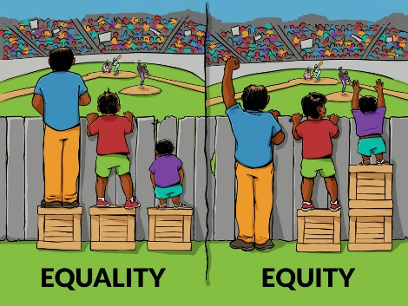
- Write a journal response: What is the purpose of
work? How do you think that work contributes to
our society?

