Entrepreneurial Thinking - Teacher's Guide / Lesson Plan

Powerpoint

Time allowance: 80 minutes (with all videos played)

Slide 2: What would you do if you came across a monster on a bridge?
- Think/ Pair / Share activity

Slide 3: Review possible answers to slide 2
- there is no right answer it depends on the person’s outlook and personality
- Ask students: What options get you home quickest? What options are riskiest?

Slide 4: (optional) viewing of the billy goat’s gruff story.
- Novelty video for understanding of how we can reach success by different approaches

Slide 5:
- definition of an entrepreneur
- Explain who they are/what they do to some people who might not know the word

Slide 6: Dragon’s Den / Shark Tank episodes to get a feel for what entrepreneurs do

Slide 7: Questions to ask the class their opinion on entrepreneurs and the video.

Slide 8: Activity: draw a bicycle (as a hook for growth mindset thinking)
- get students to draw a bicycle with room on the right to write down their thoughts as they do it
-might be thinking “i hate this” “I can’t do this” “I am bad at this” etc.
-good way to introduce growth mindset and entrepreneurial thinking

Slide 9: Explain how the traits of an entrepreneur relate to Growth Mindset

Slides 10,11,12: 3 traits of entrepreneurial thinking

Slide 13: (optional) watch video of a young aspiring movie producer reflecting on a full length movie he made and the obstacles that came with it. (30 mins long)
- talks about obstacles to funding, location shooting, working with others and how he tried to overcome it
- Talks about his expectations vs. reality in an honest way and how he’s grown since.

Slide 14: Identify goals or issues in your life where you can apply entrepreneurial thinking
(e.g. success at school, work, sports, personal health, social, family)

Slide 15: Have students take out a piece of paper and write a reflection, “ticket out the door”
- identify a goal they had in the past, obstacles that got in the way, how they tried to find a solution.
- Example: perfect attendance and starting to bike to school
  - You could mention how in the example you could blame the brother and keep being late, never changing your outcome, or you could take matters into your own hands.
-This can be their formative assessment piece

Summative Assessment: Advice Column

-Students will describe a goal in their lives, and a dilemma that is getting in the way of achieving that goal.
-it doesn’t have to be true to their lives but has to be a realistic problem
-Students must write down the question on a piece of paper
-Address it to “Ask Anonymous” and sign it with an alliteration e.g. “Sleepless in Seattle”

-Students will put their question in a hat and once everyone is done each will draw one out of the hat to answer on a piece of paper or make a vlog.
-Students must use entrepreneurial thinking strategies to offer reasonable answers
-Students must come up with 3 possible solutions

(((See below for handout to students)))

Optional activity ideas:
-Turn the solutions to these problems into a skit to show the class.

-If at the beginning of the semester, they can make a goal for this semester and explain about how entrepreneurial thinking can get them on the path to attainment

- Jia Jiang - Entrepreneur - made a series of videos on failure therapy
Jia Jiang adventures boldly into a territory so many of us fear: rejection. By seeking out rejection for 100 days -- from asking a stranger to borrow $100 to requesting a "burger refill" at a restaurant -- Jiang desensitized himself to the pain and shame that rejection often brings and, in the process, discovered that simply asking for what you want can open up possibilities where you expect to find dead ends.
-Ted Talk: https://www.youtube.com/watch?v=-vZXgApsPCQ
-Youtube channel with examples of challenges: https://www.youtube.com/user/DukieAjah/videos

“Ask Anonymous”

Part 1: Create your question
-Start with “Dear Ask Anonymous”
-Pick a goal you want in your life (or something realistic for someone your age) and describe it.
(e.g. success at school, work, sports, personal health, social, family)
-Describe an obstacle that is getting in the way.
-Finish up by asking for help on the matter.
-Sign it with a creative fake name e.g. with an alliteration
e.g. “Sleepless in Seattle”, “Bankrupt in Burnaby”, “Jumbled Jim”, “Chatty Kathy”

Example:
Dear Ask Anonymous,

I am trying to do better in math this year. Last year I got a C-, but this year I want at least a B. I am trying to focus on my work, but the only problem is I sit with my best friend and he is always distracting me by showing me memes on his phone. What should I do to focus more?

Sincerely,
Distracted Dan

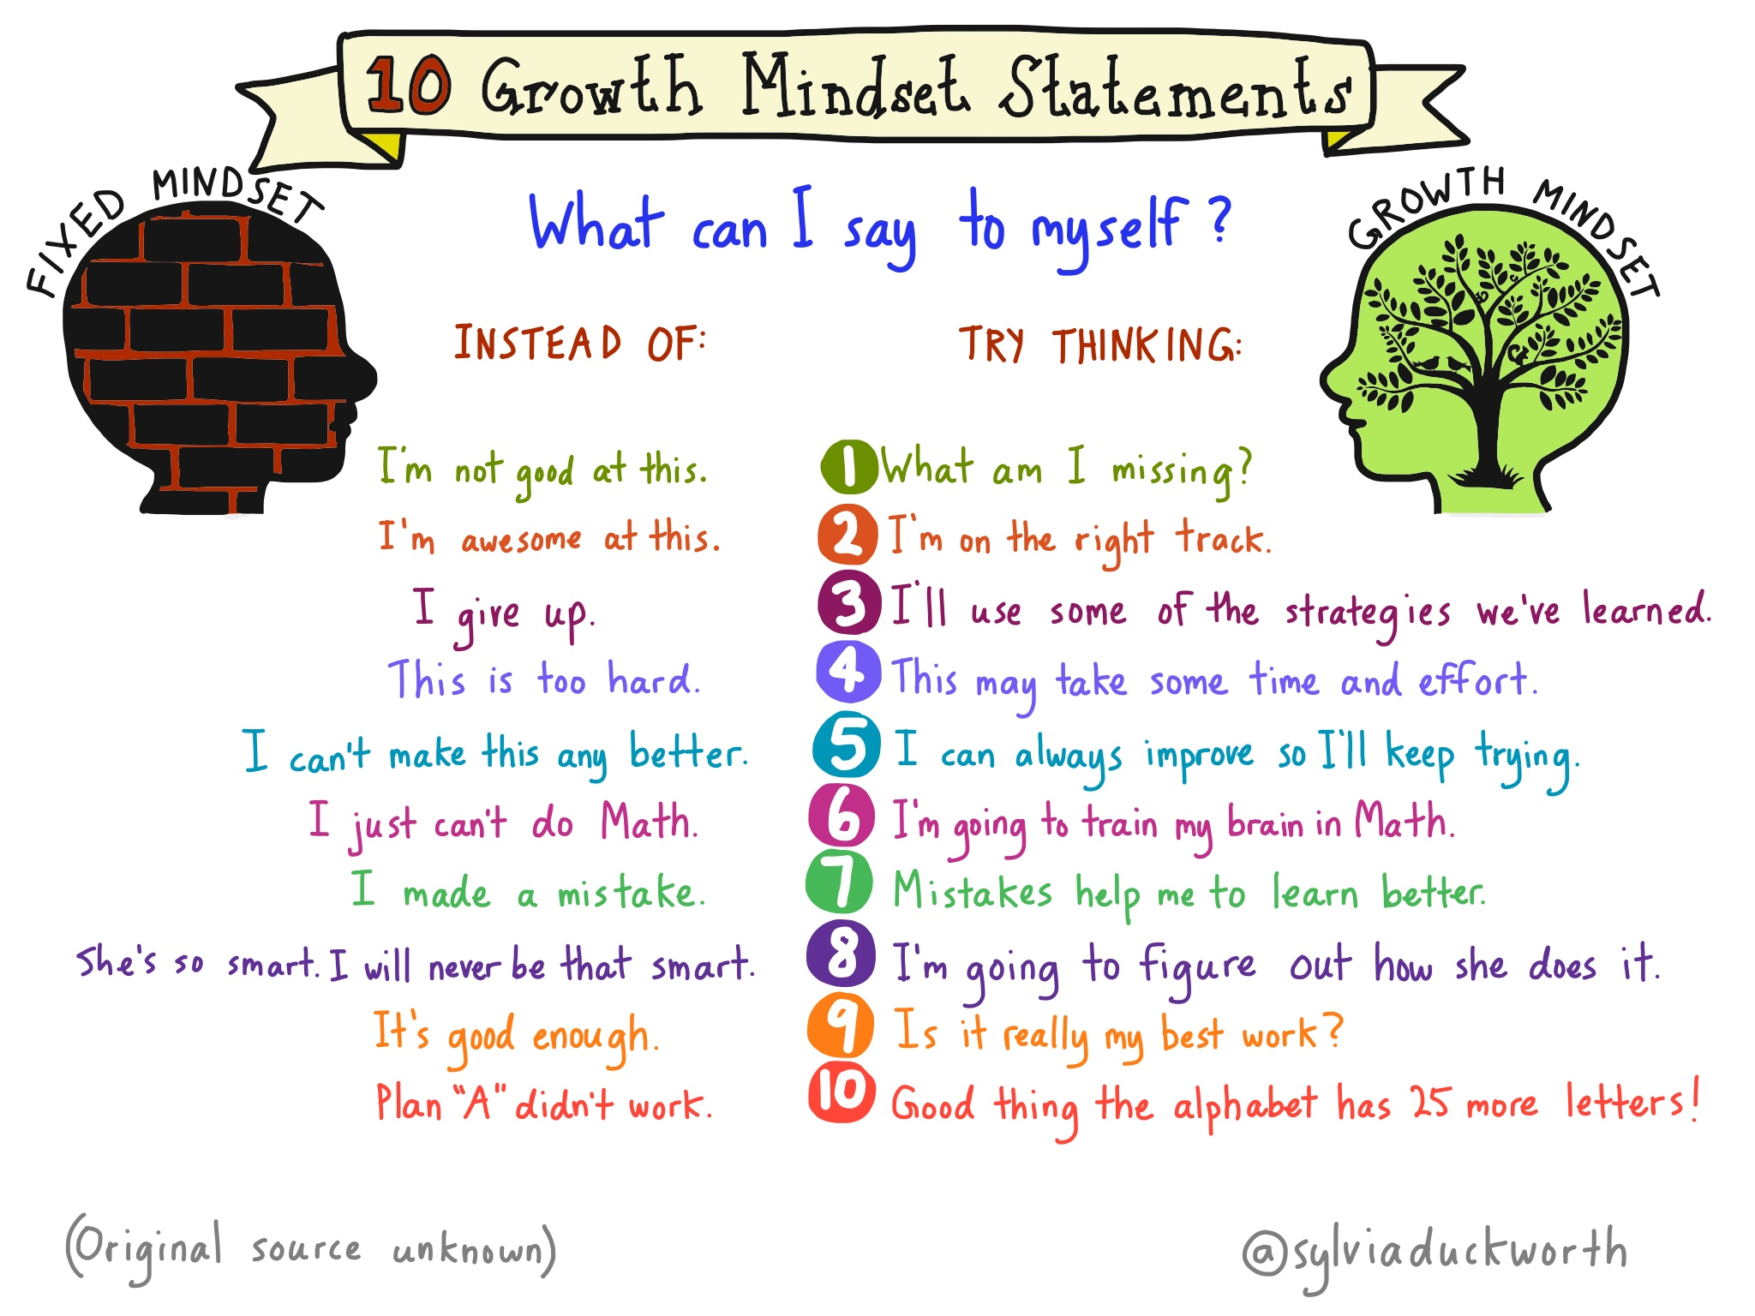

Part II: Write your answer
You will draw from a hat someone else’s question for you to answer.
Use entrepreneurial thinking to formulate your answer.
-Start by addressing the validity/seriousness of the person’s problem.
-Offer 3 different solutions in your answer.
-Reassure them there is a solution and that their situation is not hopeless.
-Sign it “Ask Anonymous” (put your real name in brackets)

Example:

Dear Distracted Dan,

Math is a very important subject to pay attention in. Math is a fundamental skill that sets you up for many important careers and financial planning in the future. Good on you for trying to improve yourself in this subject. It can be hard when a good friend, who means well, is coming in between you and your learning. I offer these suggestions:
- When your friend goes to show you his phone, keep your eye on the teacher and politely reject his distraction.
- Be sincere with your friend, sit him down and tell him that your grade in math is really important to you and tell him he must stop distracting you.
- If this doesn’t work, ask the teacher to seat you away from your friend.

I am sure your friend will understand if you explain how important your grade in math is, but if he isn’t willing to listen, do not despair! Ask your teacher for help and they will appreciate you trying to change up your environment for better learning.
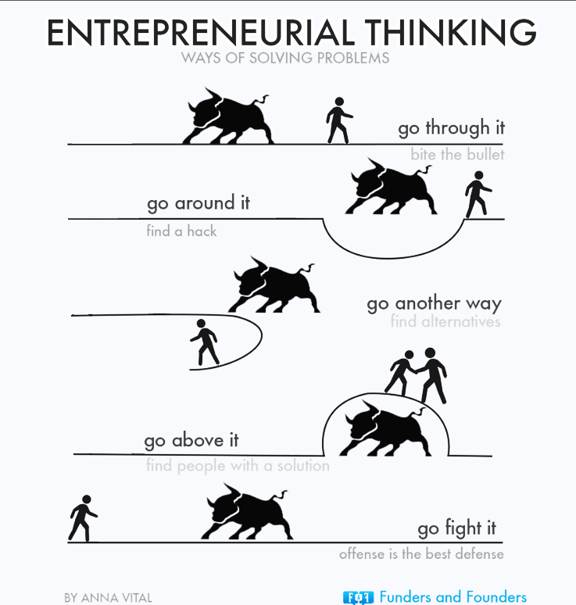
Sincerely,
Ask Anonymous (John Smith)

