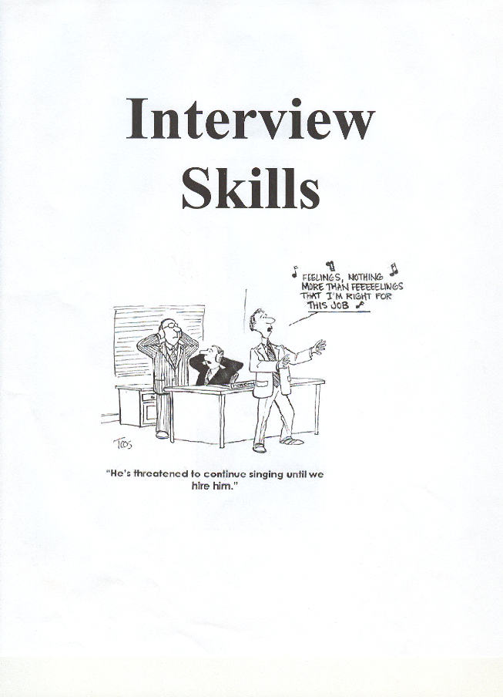

Seven Stages of a Job Interview
- Preparation
- Know what you are going to wear – prepare the night before
- Know your answers to tough questions – rehearse until you feel comfortable with your answers
- Prepare a question for the interviewer
- Know how to get there and plan to arrive 15 minutes early
- Research the company

- Opening
- Introduction
- Shake hands
- Smile

- Investigating
- Ask job related questions to get the information you need about the job

- Selling
- Sell yourself!! Make sure that you do not leave the interview without mentioning your skills and strengths

- Handling Objections
- Overcome any objections by the interviewer to hire you by knowing how to answer difficult questions

- Closing
- Thank the employer for the interview
- State your interest in the position
- Ask for a decision date
- Shake hands

- Follow-up
- Send a thank you letter / note right away (within 24 hours)
- Follow up with any promised calls

- The Interview Summary

What Employers In BC Are Looking For
(Results of a Business Council of BC Survey, 1999)

- Communications Skills
- Good Work Ethic
- Flexibility and Adaptability
- Ability to Analyze, Evaluate & Problem solve
- Positive Attitude
- Acceptance of Responsibility
- Technology skills
- Leadership and Management Skills
- Honesty and Reliability
- Willingness to Continue Learning
- Intelligence
- Creativity and Innovation
- Ethical Behaviors
- Professional and Mature Behavior
- Enthusiasm

Most Commonly Asked Questions

Q: "So, tell me about yourself"
This question may be used to assess your personality, preparation, communication skills and ability to think on your feet. Prepare a list of what you do (your current or last job), your strengths (stick to job-focussed skills), and a summary of your career trajectory, linking your experience to the job at hand.

Q: “Tell me about your hobbies, extra-curriculars, or what you do with your spare time.”
Supply information about your activities that would benefit the company or relate to the job for which you are applying. This will indicate to the employer things like your ability to work with others in a team to accomplish a goal, your ability to follow instructions, your perseverance to practice and work hard to achieve a goal, you dependability and commitment to a project, etc. It also indicates if you use your spare time to be creative and productive. Give examples to show you are active rather than passive (sit at home and watch TV, play video games, etc.)

Q: “How are you doing in school? What courses do you like the best? The least? Why?”
Be honest. Summarize the grade you are in and emphasize your strong subjects. Try to emphasize your strengths in relation to the job that you are applying for. If it is a banking, you should emphasize that you are good at math. Physical labour job – good at PE; secretarial job – proficient keyboarding skills.

Q: "Why did you leave your last job?"
Respond positively — "...for better career advancement or promotion opportunities, increased responsibility, more greater variety at work..."

Q: "Why do you want to do this job / work for this company?"
Demonstrate your knowledge of the company and re-emphasise your suitability for the position.

Q: "What do you think you have to offer this company?"
This is a chance to sing your own praises — concentrating on the skills you have that are required for the position.
E.g. "I have strong sales skills, am a good team player and am very keen to be involved in the new markets you are developing in the Asian region."

Q: "What do you think this position involves?"
This question is designed to reveal if you have thought about the position, done some research, listened to the interviewer, and can summarise all of this information clearly.

Q: "What do you know about the company?"
Demonstrate your interest in the job, and your understanding of the organisation and industry. Talk about the research you did into the company's key areas of interest, its size, its main customers or current status, making reference to your source of information.

Q: "What do you believe are your key strengths?"
Relate your strengths to the work you are applying for. Demonstrate that you know yourself well and are realistic about your confidence in doing an excellent job.

Q: "What do you believe are your weaknesses?"
No-one readily admits real weaknesses in an interview situation. It is general knowledge that this is an opportunity to turn the question into a positive. Think of something that relates to your experience of work that is plausible as a weakness but is not really a negative point. Eg; "I am very particular about detail", "I become very focussed on the projects I am involved in." Avoid anything which would be perceived as impairing your ability to do the job or that is irreversible with experience.

Q: "What do you enjoy most about your current / last job?"
The trick with this question is to list what you have enjoyed about work that strongly relate to the key competencies of the position in question, and mention that you are looking forward to expanding your experience / scope in these areas.

Q: "Where do you see yourself in five years time?"
This is an assessment of the extent of your ambition and career planning. You should demonstrate that your long term goals are appropriate for the position being discussed and your commitment to them.

Q: "Can you give me an example of your creativity / managerial / organisational skills?"
Think of some examples that prove that you possess the key attributes and competencies requested in the job ad and description. These are probably the areas on which your interviewer will probably focus.

Q: "Do you work well under pressure?"
Answer with a 'yes', and give a specific example of a time when you were under pressure and how you rose to the challenge.

Q: "Tell me about when something went wrong"
Q: "Tell me about a time when you have encountered conflict in the workplace"
Q: “What experience have you had dealing with money in a work environment?”
Q: “What experience have you had dealing with mad/upset people? How did you handle the situation?
Q: "Have you ever had to deal with conflicting deadlines? How did you decide which task to complete?"
These are behavioural questions designed to elicit information about the required competencies for the position. Cite experiences in your past jobs, and always try to inject a positive note into your answer (e.g. that you learnt from the experience).

Q: “What motivates you?”
Q: “Who is an inspirational person in your life right now?”
Q: “Do you like routine work? Regular hours? Explain.”
Q: “Do you prefer working with others or being by yourself? Explain.”
Q: “Do you consider yourself a leader or a follower? Explain.”

Q: “Can you travel? Work overtime? Are you willing to relocate?”
This is an indirect way of determining if family responsibilities tie you down. Indicate that you are flexible and can respond to the needs of the job.

Q: "Do you have any questions you would like to ask?"
Always prepare a question to ask the interviewer. Ask about the position, request clarification of general information about the company, or summarise your understanding and request confirmation. If they have already answered your questions tell them (be specific) so they know that you have thought about the position in preparing for the interview.

When asked to identify the biggest mistakes recent college graduates make during the application and interview process, employers cited the following:
- Acting bored or cocky
- Not dressing appropriately
- Coming to the interview with no knowledge of the company
- Not turning off cell phones or electronic devices
- Not asking good questions during the interview
- Asking what the pay is before the company has considered them for the job
- Spamming employers with the same resume and/or cover letter
- Failure to remove unprofessional photos/content from social networking pages, web pages, blogs, etc.
Dress the Part

Your attire, like your demeanor won’t get you the job by itself, but it sets the stage for the deeper conversation. If you dress poorly, they will infer negatives – that you are naïve, or that you don’t understand the job or company culture. Dressing well can even overcome prejudices. For example, an older candidate can dress in a stylish, contemporary outfit, which gives the impression that she’s energetic, and up-to-date. Likewise, an entry level candidate in a smart, professional suit sends the message that she knows how to act in a business setting.

The simplest rule to follow: Dress in standard business attire.

For Men:
- A suit and tie (if applicable); A well-fitted, well-styled suit makes you look successful.
- You could also wear dress pants, a solid coloured sweater with a collared shirt underneath.
- Wear dress shoes – polished and in good condition. No athletic foot-wear, runners, skate shoes, etc.
- The colour of your socks should complement your pants and shoes.
- A solid coloured shirt. When in doubt, wear white. A tee-shirt underneath helps prevent noticeable perspiration.
- If wearing a tie, make sure it is of conservative colour/pattern.
- Easy on accessories - flashy watches, attention-grabbing eye glass, or other jewelry.

For Women:
- A suit with a skirt or dress pants is the standard interview outfit.
- Shirt should be conservative style, colour, and fabric.
- Covered shoulders, a tailored jacket or cardigan may be worn.
- Skirt length just above the knee (nothing shorter).
- Do not wear anything too tight, revealing or sloppy.
- Polish those dress shoes, no overly high heels, no open toes.
- Wear minimal jewelry, avoid jangly bracelets, wear small earrings.
- Natural looking makeup.

Other
- Be conservative with accessories like a purse or briefcase.
- In most business settings, a backpack looks silly with a suit, so carry your résumés in a portfolio.
- Make sure you shower or bath beforehand – absolutely no body odour!
- Good oral hygiene: brush and floss, clean tongue, fresh breath.
- Clean hair in a conservative style. Keep hair off of face and eyes visible. Males keeps your facial hair trimmed and neat.
- Clean, well-maintained fingernails. Males – short; Females – short to medium, clear or pale polish, never chipped.
- Fragrance – be very careful with fragrance, many companies have a no scent policy. Your interviewer may be allergic to perfume/cologne.

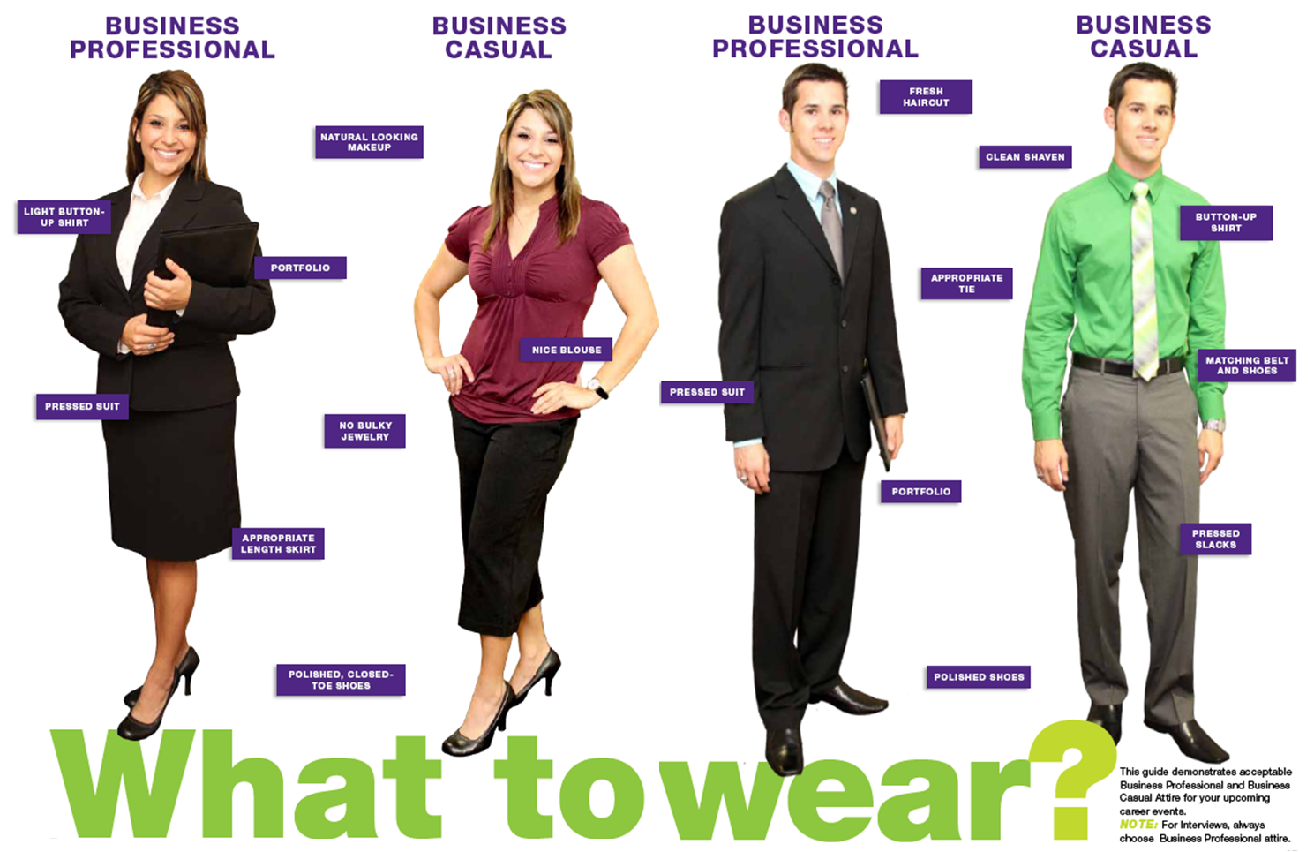
FIRST IMPRESSIONS

- Smile: A friendly face is more pleasant than a grim face. It helps put the interviewer and yourself at ease.

- Be Ready to Shake Hands: Be alert and quick to respond to the interviewer both at the beginning and end of the interview. If the interviewer offered to shake hands at the beginning, then you offer first at the end.

- Maintain Eye Contact
If you don’t, many people feel that you are lying or not dependable.

- Be attentive to body language: Stature gives you presence. In the waiting room sit tall, smile at people walking by, and remain alert. Do not sit in the waiting room on your phone. In the interview, sit up straight in your chair, leaving your feet flat on the floor. Keep your shoulders square to the interviewers. Cross your legs only at the ankles to avoid setting a barrier. This is a subtle way to let them know they have your full attention. Don’t cross your arms across your chest. Don’t place anything on the desk between you and the interviewer. Hold your portfolio on your lap with one hand leaving the other free or place hands gently on lap without crossing. Avoid nervous habits.

- Consider Each Interview a Challenge
Be enthusiastic about potentially working for that employer and about the job.

- Shut the Door On Your Troubles
Try to avoid discussions about family or financial problems. Think positively about what you can do for the employer.

- Don’t Chew Gum or bring coffee with you into the interview. A water bottle is ok.

- Sit Down When You Are Invited To
If you have a choice sit as near to the interviewer’s desk as possible, and face the interviewer. Don’t lean or place anything on the interviewer’s desk.

TEN COMMANDMENTS OF GOOD LISTENING
(TURN OFF CELL PHONE BETTER YET DON’T TAKE IT INTO
THE INTERVIEW WITH YOU)

- Stop talking – you cannot listen if you are talking

- Put the talker at ease – smile, listen with your eyes, your face, your body and your emotions as well as your ears

- Indicate that you want to listen – Look and act interested, listen to understand rather than to reply

- Remove distractions – do not doodle, tap or shuffle, tap or shuffle papers

- Empathize – Put yourself in the speaker’s place so that you can see their point of view, “walk a mile in his moccasins”

- Be patient – allow plenty of time, do not interrupt

- Hold your temper – when you are angry you often get the wrong meaning

- Go easy on criticism and argument – the speaker often gets defensive, do not argue, even when you win – you lose

- Ask questions – this is encouraging and helps to develop further communication

- Stop talking – this is the first and last, because all other commandments depend on it

People have two ears but only one tongue - - a gentle hint that we should listen more than we talk

THE INTERVIEW: WORKPLACE EXPECTATION

The following is a visual review chart emphasizing expected behaviors during an interview. How you conduct yourself during the interview should reflect the assertive column in the center as opposed to the outside columns labelled passive and aggressive.

Assertiveness is the workplace expectations.

 | Passive | Assertive | Aggressive
Voice:  The tone of voice when speaking and the pitch | - Weak, meek  - Whispers  - Shaky | - Moderate tone  - Clear  - Confident | - Loud  - Abrasive  - Forceful
Handshake  The manner in which you shake another person’s hand | - Dishrag feeling  - Loose arm | - Firm grip  - Confident shake | - Strong grip  - Pumping arm
Eye Contact  Looking sat the person you are speaking to | - Rarely looks at person  - Eyes down  - Looks around room  - Appears to have something to hide | - Maintains eye contact  - Occasionally looks elsewhere  - Faces employer  - Smile | - Stares down employer  - Glares  - Controlling
Body Language  What you are doing with your body during the interview | - Fidgets with hands  - Keeps shifting in sear  - Kicks legs  - Shakes or nods head too much | - Sits upright and slightly forward  - Appears interested  - Hands in lap or folded  - Relaxed | - Hands clenched  - Leans too far forward and invades interviewer’s “space” (less than one meter)
Space  The room between two people when communicating in an interview | - 3 meters away (poor) | - 1.5 meters (acceptable) | - Less than 2 meter (inappropriate)
Being Seated  Asked to take a chair | - Is offered a seat and must be asked twice  - Or sits in seat furthest away | - Waits to be offered a sear, then sits  - Or asks where would you like me to sit? | - Walks in and sits down  - Begins speaking immediately
Discussing Yourself | - Give one word answers  - Replies only “yes” or “no”  - Rarely expands on a question | - Speaks positively  - Speaks confidently  - Stresses qualifications  - Is prepared to elaborate on self | - Over exaggerates about self  - Tends to brag  - Controls interview  - Interrupts
Closing the Interview | - Says thank you and rushes out of the office | - Shakes interviewer’s hand  - Thanks interviewer  - Indicates that she/he hopes to hear from the interviewer shortly | - Over shakes hand  - Forces immediate decision re: hiring

