This activity will help students explore the challenges, accomplishments and their ability to transition from one life event to the next. Complete each section by following the instructions below.
Teacher Led | X | Requires Computer | X | Requires myBlueprint.ca | X

LEARNING GOALS:
- Students will explore all aspects related to transitioning between life stages.
- Students will understand the challenges and necessities of transitioning.

MATERIALS:
- Writing tools
- Computer, mobile device, or tablet
- Handout [A] - Life Map Expectations
- Handout [B] - My Life Map Template
- Life Map Rubric

INSTRUCTIONS:
- Give students the handouts and have them create a Life Map, outlined in Handout [A]
- Provide them with Handout [B] to help them create a life map
- Once students are done, have them complete the Reflection Questions in Handout [A]
- Invite students to take a picture of their Life Map and upload it to a “My CLE Portfolio” on myBlueprint. Students can add a reflection (+Reflection) to the picture (i.e., Life Map) they added to their portfolio. This reflection can be the answers to the Reflection Questions in Handout [A].

**See below for a Life Map Rubric
CRITERIA | Level 4 | Level 3 | Level 2 | Level 1
Content | All events contain clear and relevant details explaining significant event. | Most events contain relevant details explaining significance of event. | Events contain some details explaining significance of event. | Events contain few details explaining significance of event.
Creativity | Life map is extremely visually appealing. Map is extremely neat, original, and color is used to significantly enhance overall appeal. | Life map is visually appealing. Map is neat, original, and color is used to enhance overall appeal. | Life map is somewhat visually appealing. Map is mostly neat, original, and color is somewhat used to enhance overall appeal. | Life map lacks visual appeal. Lacks neatness, originality, and color is not used to enhance overall appeal.
Organization | Information is in chronological order. Clear explanation of transitions between events. Reader is not left with any questions. | Information is in chronological order. Explanation of transitions between events leaves reader with few questions. | Information is somewhat out of order. Weak explanation of transitions between events. Reader has difficulty understanding. | Information is out of order. Very limited explanation of transitions. Reader is not able to follow events in life map.
LIFE MAP RUBRIC
Name: __________________________________

Teacher Comments:

/15

HANDOUT [A]: LIFE MAP EXPLORATION
- Create a colourful map showing your life to date
- Start with your birth, and as you go along the road of your life, mark the ups and downs in the events that happened to you
- Identify the TRANSITION process you went through from one event to the other (How did you get through it? What new skills did you learn?)
- Put up to 10 different events on your map
- You can use the template below or create your own. Add the following things to your map:
  - Dates, places, events, signs, symbols, pictures, transitions, etc.
- Answer the following reflection questions:
a. What accomplishment are you most proud of? Why?
_________________________________________________________________________________________________________________________________________________________________________________________________________________________________________________________________________________________________________________________________________________________________________________________________________________________________________
b. What obstacle was the hardest to overcome? Why?
_________________________________________________________________________________________________________________________________________________________________________________________________________________________________________________________________________________________________________________________________________________________________________________________________________________________________________
c. What strategies did you use to manage the changes in your life?
_________________________________________________________________________________________________________________________________________________________________________________________________________________________________________________________________________________________________________________________________________________________________________________________________________________________________________
d. What skills or strategies did you gain by overcoming these obstacles?
________________________________________________________________________________________________________________________________________________________________________________________________________________________________________________________________________________________________________________________

7. Take a picture of your Life Map (if created it on paper)
8. Log in to your myBluprint account.
9. Go to Home and select Portfolios.
10. Select your My CLE Portfolio (or click + Add Portfolio).
9. Add your Life Map to your portfolio (Click + Add Box > select Media + > click Upload File or Upload Picture > Add Title “My Life Map”)
10. Add a reflection to your Life Map Picture/File Box (click +Reflection). Add your answers to the Reflection Questions in Handout [A].

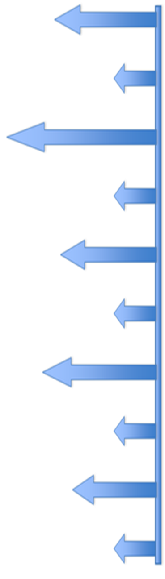
HANDOUT [B]: MY LIFE MAP TEMPLATE

