Name: _____________________

What Are You Made Of?
CLE Skills Careers Exploration:

When people think about the skilled trades, several immediately spring to mind – electrician, plumber, welder, carpenter, for example. But opportunities in the skilled trades are much more extensive. From hairstylist to cook, painter to landscaper, automotive service technician to crane operator – and so many more. With hundreds of skilled trades careers to choose from, there are opportunities available to suit almost any interest. What’s more is that many in the skilled trades have better employment outcomes, better earning potential, and higher levels of job satisfaction and job security than those in other career areas. The skilled trades are vaster than you may realize. “What Are You Made Of?” offers a glimpse of these important professions and connects you based on your own unique qualities.

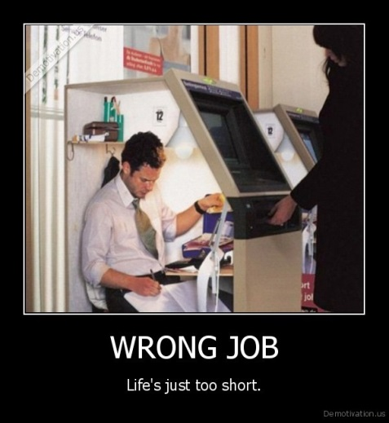

Task: Investigate and learn about potential skilled trades careers. Evaluate their suitability for you and your future.

Steps:
- Go to the ITA’s “What Are You Made Of?” website located at http://www.itabc.ca/youth

- Read through the various descriptor words that may describe you. Read them all first before selecting the 10 that best suit you.

- Record the 3 Trades Careers selected for you here:

_____________________ _______________________ ___________________

- Click on each of the 3 suggested trades. Read the job description, the income, what you learn in the job and who you work for. Do this for all 3 of the trades matched for you.

- Click on 1 other trade that you have considered or that you are interested in that was not in your top 3 recommendations. Read the job description, the income, what you learn in the job and who you work for.

- Click on 1 trade that you have no prior knowledge about, a trade that you may have never heard of before. Read the job description, the income, what you learn in the job and who you work for.

- Complete the following “What Are You Made Of?” research and response sheet for 1 trade suggested for you, and 1 trade of your choice. Be prepared to share and present on your findings in groups and with the class as a whole.
“What Are You Made Of?” Research and Response Sheet
Trade: ________________________________
What You Do?
Make notes and summarize in your own words what this trade does, the type of work as well as working environment:
What to Expect?
Make detailed notes on yearly wage, hourly wage, average work week and the best places to find work in this trade in B.C.
What You Learn?
Make notes and summarize in your own words what skills and activities you learn through this trade
Who You Work For?
Make notes and summarize in your own words the options available for employers and places of work

- What about this trade do you like? What was surprising? The work, the wage, the job prospects? Explain.
__________________________________________________________________________________________________________________________________________________________________________________________________________________________________________________________________
- What about this trade does not appeal to you? The tasks, the wage, the working conditions? Explain.
__________________________________________________________________________________________________________________________________________________________________________________________________________________________________________________________________
- What can you do now and in the near future to prepare for this profession? What high school courses could you take? What Surrey Apprenticeship Programs could you take? What work experience or volunteering can you participate in? Discuss with your peers and teacher. Record all possibilities.
____________________________________________________________________________________________________________________________________________________________________________________________________________________________________________________________________________________________________________________________________________________
_____________________________________________________________________________________
“What Are You Made Of?” Research and Response Sheet
Trade: ________________________________
What You Do?
Make notes and summarize in your own words what this trade does, the type of work as well as working environment:
What to Expect?
Make detailed notes on yearly wage, hourly wage, average work week and the best places to find work in this trade in B.C.
What You Learn?
Make notes and summarize in your own words what skills and activities you learn through this trade
Who You Work For?
Make notes and summarize in your own words the options available for employers and places of work

- What about this trade do you like? What was surprising? The work, the wage, the job prospects? Explain.
__________________________________________________________________________________________________________________________________________________________________________________________________________________________________________________________________
- What about this trade does not appeal to you? The tasks, the wage, the working conditions? Explain.
__________________________________________________________________________________________________________________________________________________________________________________________________________________________________________________________________
- What can you do now and in the near future to prepare for this profession? What high school courses could you take? What Surrey Apprenticeship Programs could you take? What work experience or volunteering can you participate in? Discuss with your peers and teacher. Record all possibilities.
____________________________________________________________________________________________________________________________________________________________________________________________________________________________________________________________________________________________________________________________________________________
_____________________________________________________________________________________

