Mind your manners: Etiquette tips for a shifting business landscape

BY JENNY LEE, VANCOUVER SUNJANUARY 15, 2016

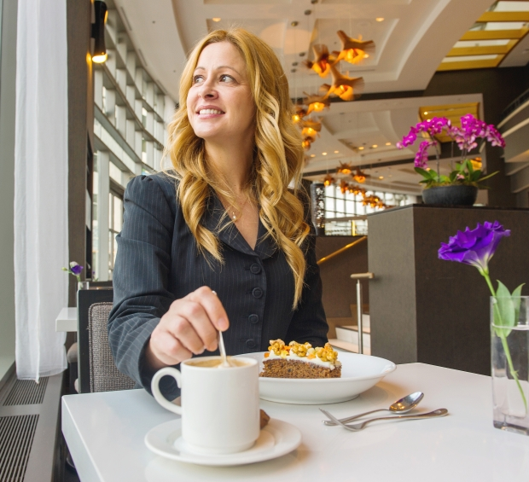

Etiquette consultant Carey McBeth quietly stirs her coffee at Arc Restaurant in the Fairmont Waterfront hotel.

Photograph by: Gerry Kahrmann, PNG
Job hunters beware: many employers are interviewing potential employees over meals.
“They want to see how (candidates) handles themselves in social situations,” etiquette trainer and coach Carey McBeth said. “Because 60 per cent of business is done over a meal, there’s a lot of room for social gaffes.”
Although Vancouver is renowned for its laid back vibe, business etiquette is increasing in profile as the city sees more global business, said McBeth, who has been teaching etiquette since 2002.
“I have definitely seen an increase over the last couple of years in my business from the Asian market as well as from lots of international students,” she said. “Knowledge is 15 per cent of why you’re going to get the job. The rest is social skills.”
Etiquette isn’t about archaic rules, but about building relationships, and dining etiquette has become McBeth’s most popular business offering.
“We often see job interviews take place in the restaurant,” said Fairmont Waterfront’s Arc Restaurant and Bar general manager Richard Curtis. “It’s discreet, yet still in a social setting.”
At lunch, don’t talk business until after you’ve ordered, McBeth advises. At dinner, don’t talk business until after the main course. Employers “really want to see how you’re going to act. Are you going to be sloppy and embarrassing for the company or able to handle yourself?”
McBeth’s No. 1 piece of advice for job interviews conducted over a meal?
Don’t put your cellphone on the table.
“It tells the person across from you that (the phone) is more important than them,” McBeth said. “Millennials live on their smart phones and it’s hard to put them away sometimes, but when you’re trying to establish business relationships, the phone has got to go.”
McBeth gets challenged on this all the time by business people who say “I’m important and I need my phone.” Her rejoinder: are presidents or prime ministers ever seen with cellphones?
“If you’re that important, you’re going to have assistants who are going to take care of things while you’re in that meeting.”
Whatever you do, don’t order spaghetti.
Order something you can eat discreetly with minimal fuss and mess. Don’t order an expensive menu item. That signals you might not be financially responsible.
The employer is hosting you, so follow their lead. Sit down when you’re cued.
“When they take their napkin down, you take your napkin down,” McBeth said.
And don’t worry about the bill. That’s the potential employer’s responsibility.
Realize you may be observed both before and after the interview itself.
When interviewing job candidates, “I watch body language when people leave,” Curtis of the Fairmont Waterfront said. “I like to see how people carry themselves.”
At networking events, remember you’re not there to eat, but to build business relationships and that means you’re going to be talking, McBeth said.
Avoid overloading your plate. Better yet, arrive on time, eat and connect with the event organizers while the room is still relatively empty.
Don’t eat cheese.
“Cheese causes instant bad breath,” McBeth said.
After eating, visit the washroom to freshen your face and teeth. When the room starts to fill, you’ll be able to talk, shake hands and exchange business cards without trying to juggle a wine glass or appetizer plate.
“For women, make sure you have your business card accessible so you don’t have to dig in your purse,” McBeth said. “Hold whatever you’ve got in your left hand because your right hand needs to be available to shake hands.”When McBeth started her business 13 years ago, she knew of only one other etiquette coach in town. Now there are probably five boutique business, as well as courses offered by large training companies.
Nina Durante of Social Graces is one of those boutique newcomers.
Durante believes the etiquette industry is growing along with global business and Vancouver’s multicultural makeup is increasing demand for etiquette training in the city.
Etiquette covers not only multicultural differences but intergenerational ones, Durante said.
“For the first time, you could have four different generations in the workplace at once: your pre-baby boomers, baby boomers, Gen X and your millennials,” Durante said. “The millennial is going to ask ‘Why?’” The pre-baby boomer will say “Because I said so,” Durante said.
Cultural differences abound. It’s polite to flip your chopsticks over when picking up sushi from a communal plate. At a Chinese business meal, leave a little food on your plate to show you’ve been served enough food. In a Canadian meeting, expect a team approach where everyone talks, but in a Japanese style business meeting, expect the most senior person to do all the talking, said Durante, who trained in international etiquette in London and teaches Western style etiquette.
McBeth offers a course on Canadian workplace culture for immigrants or visitors who want to be comfortable in the local business environment.
“The No. 1 problem when individuals can’t find work is they can’t guarantee they are going to mould into the workplace culture,” said McBeth, who has taught etiquette to University of B.C. engineering and arts students, Vancouver General Hospital pathology students, and multiple MBA students among others.
If you’re cycling to an interview, ask reception if there’s a place you can leave your helmet.
Bear in mind that even if the environment you’ll be working in is casual, that doesn’t mean you show up dressed the same way for the interview.
“I’ve had numerous recruiters talk about this,” McBeth said.
It’s OK to call the receptionist ahead of time and ask for clothing advice, McBeth said.
Send an immediate thank you email followed by a handwritten one. A handwritten note stays on someone’s desk anywhere from seven to 10 days, McBeth said. “You’re marketing yourself for an additional seven to 10 days.”
If you’re attending a job expo, when introducing yourself to recruiters, don’t just state your name, also say what you’re looking for and when you’re graduating, McBeth said.
Make eye contact 40 to 60 per cent of the time.
And don’t forget the handshake. The person who offers their hand first has the distinct advantage, McBeth said. “You do not have to wait for the employer or recruiter. You’re taking the initiative, showing you have confidence.”
If McBeth teaches rules about using knives and forks and how to stir a coffee cup without clinking, it’s because “you don’t want distractions to take away from what you are trying to accomplish.”
jennylee@vancouversun.com
© Copyright (c) The Vancouver Sun

